2 Start Ltd
Special Educational Needs and Disabilities (SEND) and Reasonable Adjustments Policy and Accessibility Plan

POLICY OVERVIEW

This policy sets out 2 Starts approach to supporting the delivery of high-quality provision for people with Special Educational Needs and/or Disabilities (SEND) and/or requires reasonable adjustments.

2Start is committed to ensuring that all learners have access to a high-quality learning experience and aims to support inclusion of all learners. 2 Start is fully committed to ensuring provision is made available for those who need it. Where 2 Start is unable to provide support to address a special educational need or disability, learners will be referred to the appropriate specialist provision.

The aim of this policy is to:

- Outline 2 Start’s commitment to SEND provision in line with the Department for Education’s Special Educational Needs and Disability Code of Practice and The Equality Act 2010.
- Outline 2 Start’s plan for Reasonable Adjustments and Accessibility Plan
- Outline 2 Start’s plan for supporting learners with medical conditions
- Outline and describe the systems and processes that are implemented to support learners with SEND
- Outline the responsibilities of 2 Start’s staff in relation to SEND

- SEND PROVISION

The Code of Practice 2015 defines SEND as: 'A child or young person has SEN if they have a learning difficulty or disability which calls for special educational provision to be made for them.’ Children, young people and vulnerable adults who have SEN may also have a disability under the Equality Act 2010. The Equality Act 2010 defines an individual as disabled if he or she has a physical or mental impairment that has a “substantial” or “long term” adverse effect on his or her ability to undertake normal day to day activities.

Special educational needs and disabilities (SEND) can affect a child or young person’s ability to learn. They can affect their:
- behaviour or ability to socialise, for example they struggle to make friends
- reading and writing, for example because they have dyslexia
- ability to understand things
- concentration levels, for example because they have ADHD
- physical ability

2 Start recognises that all learners should be helped to develop and achieve the skills, experience and qualifications they need to succeed in their careers. 2 Start works under the presumption that SEND learners are capable of sustainable paid employment with the right preparation and support and are committed to using our best endeavours to source the necessary provision for our learners.

2 Start Ltd will:

  - Cooperate with Local Authority arrangements for young people with Special Educational Needs (SEN). This includes signposting learners and engaging with partners identified under the Local Offer of the Local Authority where the young person lives.
  - Do our utmost to secure the SEND provision which the young person needs and is most appropriate for them.
  - Provide ‘reasonable adjustment to prevent disadvantage’.
  - Provide relevant careers guidance for SEND learners.
  - Ensure equal access to learning programmes and assessments.
  - Where appropriate, engage with other organisations in order to share information and deliver more coordinated, appropriate support for learners.
  - Where appropriate, engage with parents/carers in order to obtain / share information and support learners.
  - Review learners’ progress regularly.
  - When required, follow relevant awarding body and/or local authority reasonable adjustments processes and policy(s).

- REASONABLE ADJUSTMENTS AND ACCESSIBILITY PLAN

All staff members at 2 Start will “know their learners” and plan for their individual needs so that all learners have equal access to knowledge, lessons and facilities.

2 Start will endeavour to provide reasonable adjustments to policies and practices where necessary, to support learners where said polices and practices create a barrier to successful learning and achievement in relation to a learner’s individual SEND. Reasonable adjustments will be made, where possible, to enable learners with a disability to access learning, this may include practical aids, assistive technology, visual aids, pictorial or visual representations, large print resources, dyslexia friendly fonts, coloured paper, additional time, a reader or a scribe for examinations.
.

Although Mantra Learning must make every effort to support the needs of learners with SEND, under the Efficient Education of Others caveat in the 2015 SEND Code of Practice, the support provided must not be at the expense of the education of other learners.

- SUPPORTING LEARNERS WITH MEDICAL CONDITIONS

2 Start recognises the need to actively support learners with medical conditions to access all areas of their learning. 2Start recognises that not every learner with the same condition will require the same treatment.

Where a learner makes 2 Start aware that they have a medical condition, 2 Start will consider all reasonable adjustments that might be needed, to enable the learner to participate fully in their learning.

This may include, but is not limited to, time out of lessons, access to medications/inhalers etc whilst on-site, not penalising learners for their attendance record if their absences are related to their medical condition e.g., hospital appointments, not preventing learners from eating, drinking or taking toilet or other breaks whenever they need to in order to manage their medical condition effectively.

- PROCESS

Should a learner disclose that they have a SEND and/or are on an EHC plan then a member of the safeguarding team must be informed. The safeguarding team member will coordinate with the appropriate local authorities to make arrangements for the learner journey.

ASSESS, PLAN, DO, REVIEW
ASSESS
Learner identified for additional intervention and support.

PLAN
Quality teaching and support planned to provide best learning experience. High aspirations set to support achievement of the highest possible outcome.
DO
High quality teaching linked with support for the learner provided to ensure planned outcomes.
REVIEW
Mantra’s Review Cycle to monitor support provided, progress made towards achievement and next steps for the learner.
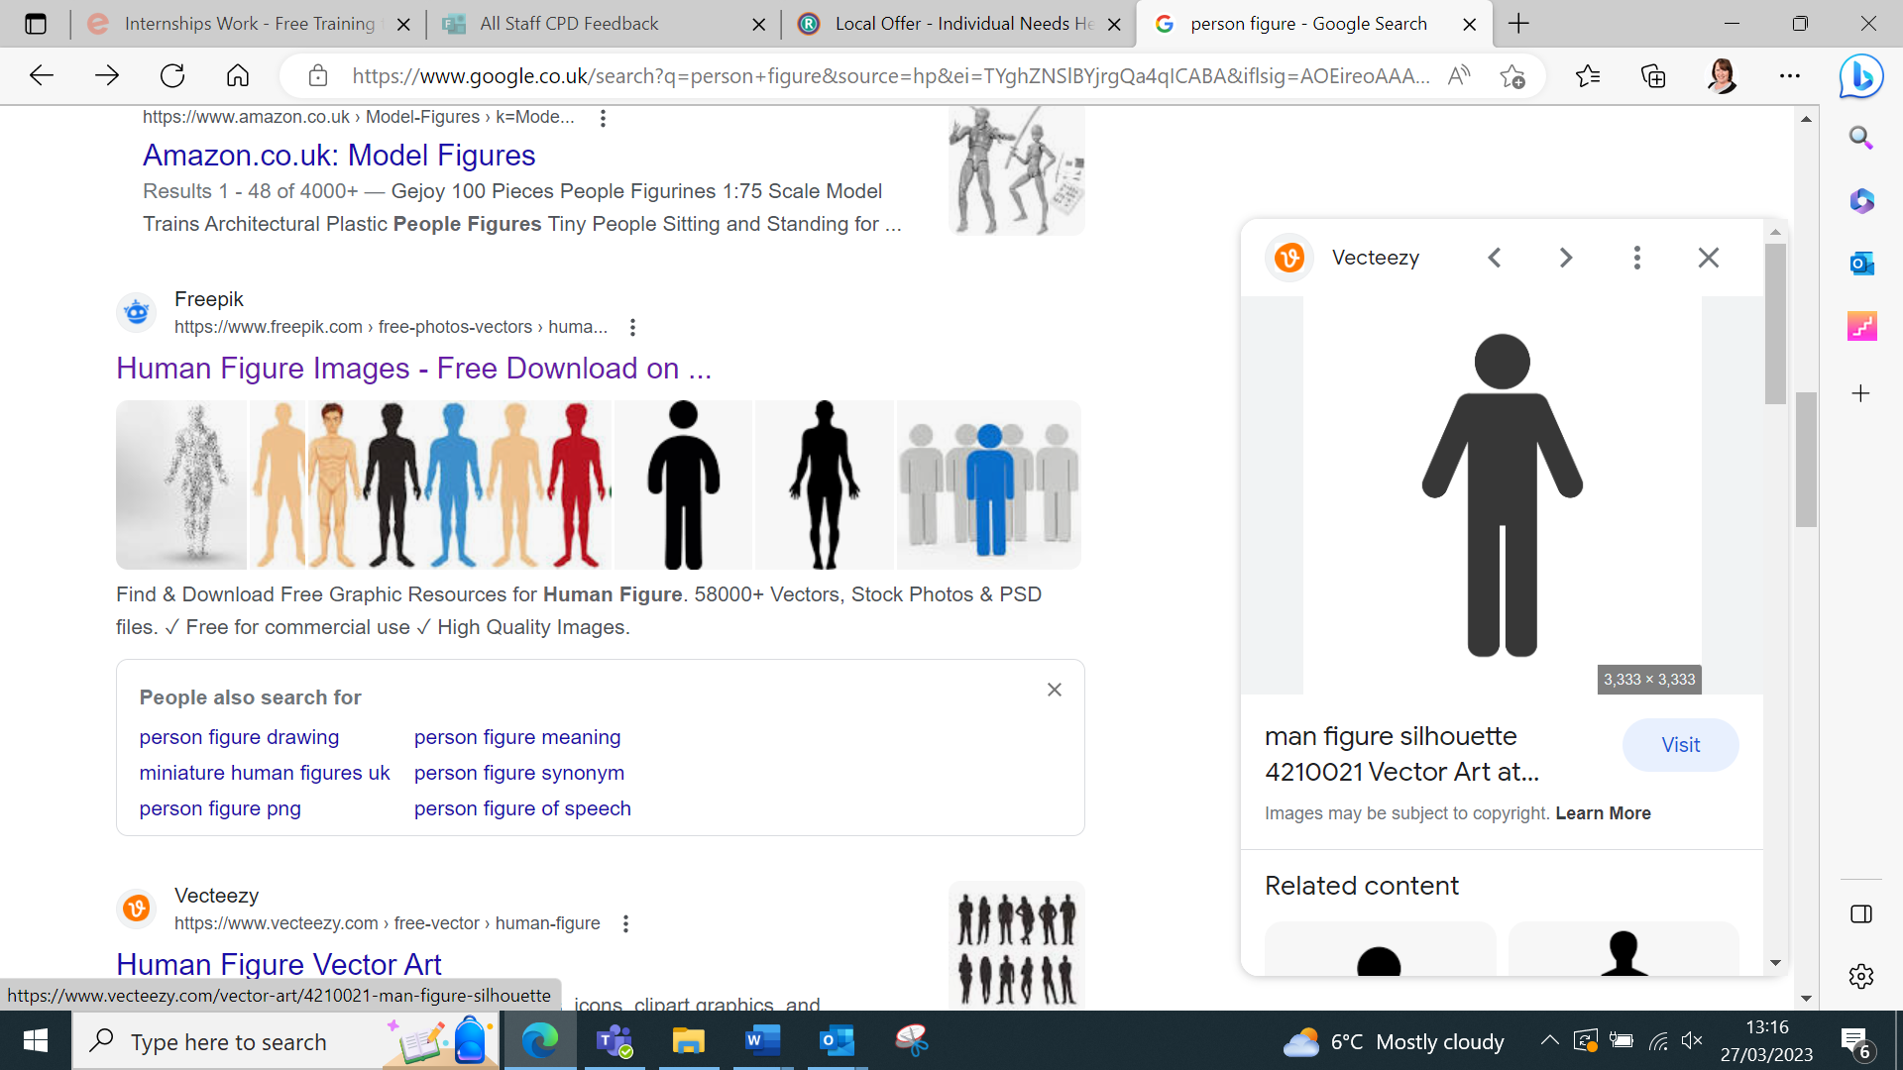

Learners who disclose that they have a learning difficulty and/or disability, that will require additional support and/or reasonable adjustments to be made, will discuss this with a member of the 2 Start team.

The support required by the learner will then be discussed and communicated to the relevant tutor, development coordinator and exams officer. If required, the safeguarding team should be notified.

Where a learner requires additional or reasonable adjustments during assessments, the exams officer must be notified prior to any assessment taking place.

The exams officer must speak to and request a reasonable adjustment following the awarding body policies and procedures. The lead invigilator should also be notified prior to the assessment to notify of a reasonable adjustment request.

Once a request has been agreed with the awarding body, the exams officer will work with the lead invigilator to ensure any reasonable adjustments are put into place prior to assessments taking place, following the relevant awarding body policy.

2 Start will try to make any reasonable adjustments and/or learning support that may be required. Where required, 2 Start will liaise with the relevant awarding body organisation, local authority or support organisation(s) that may be required for additional support and/or guidance.

Awarding body policies and procedures will be followed for any reasonable adjustment made.

- RESPONSIBILITIES OF STAFF

  - All staff will ensure that learners with SEND can be fully supported by following the process outlined above.
  - 2 Start will provide guidance to help staff understand and provide reasonable adjustments and support for SEND learners to make progress.
  - The Safeguarding team will keep a central log of all SEND learners and provision put in place to support them.
  - The Safeguarding team will support the delivery staff to ensure that all reasonable adjustments and provision can be put into place to support learners with SEND.

Policy Approval

Date: 25/8/24

Name: Caroline Moon

Position: 

Date of next review: By 25/8/25

